**Survey Completion Analysis Report**

**1. Overview of Data Collection**  
The survey dataset contained responses from a total of 577 entries, including 18 pilot test responses. After excluding the pilot test entries, the final dataset consisted of **559 valid responses** for analysis. The responses were categorized as either **complete** or **incomplete**, with a focus on understanding the completion rates of incomplete cases.

**2. Completion Status Breakdown**  
Out of the 559 valid responses:

* **328 (58.7%)** were marked as **complete**.
* **231 (41.3%)** were marked as **incomplete**.

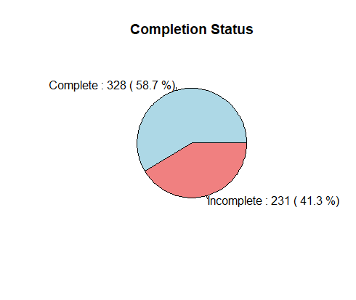

This indicates that more than half of the respondents completed the survey in its entirety, which is a positive indicator for the overall survey response quality.

**3. Analysis of Incomplete Cases**  
Among the 231 incomplete responses, the analysis revealed the following completion rates:

* **Minimum completion rate:** 39.6%.
* **Maximum completion rate:** 92.2%.

This demonstrates significant variation in how much of the questionnaire was completed by respondents who did not finish the survey.

**4. Acceptable Completion Rate Assessment**  
Research and survey guidelines suggest that acceptable completion rates depend on several factors, including the length of the questionnaire and the target audience. For long questionnaires, an **acceptable completion rate is widely benchmarked at 50% or higher**.

Using this benchmark:

* **133 (52%)** of the incomplete responses had a completion rate of 50% or above.
* **98 (48%)** of the incomplete responses had a completion rate below 50%.

This indicates that slightly more than half of the incomplete responses met the acceptable threshold for completion, even if they did not finish the survey in its entirety.

**5. Insights and Recommendations**  
Based on the analysis, the following key insights and recommendations can be drawn:

1. **Overall Survey Performance:**
   * The survey achieved a **completion rate of 58.7%** for complete responses, which aligns with reasonable outcomes for similar survey efforts and industry standards.
   * The **41.3% of responses marked as incomplete** provides an opportunity to gain additional insights from partially completed data, especially given the observed variation in completion rates.
2. **Incomplete Responses:**
   * Among the incomplete responses, a wide range of completion rates was observed, with progress ranging from **39.6% to 92.2%.**
   * The variation in these rates highlights the potential for meaningful analysis of partially completed responses, particularly those that approached high levels of completion.
3. **Completion Rate Benchmark:**
   * Using a benchmark of **50% as an acceptable completion rate** for long questionnaires, **52% of the incomplete responses** met or exceeded this threshold.
   * The remaining **48% of incomplete responses** fell below this threshold, but the partially completed data may still offer valuable insights depending on the sections completed.
   * Proceeding with the analysis of these responses can help maximize the value of the dataset without necessitating changes to the questionnaire.

**6. Conclusion**  
The survey achieved a respectable completion rate of 58.7% for complete responses and demonstrated that among incomplete cases, a majority (52%) still met the acceptable 50% benchmark.

**Annexes: R codes**

# Set working directory

setwd("C:\\Users\\albert.orwa\\Downloads")

# Load required libraries

library(dplyr)

# Read the dataset

df <- read.csv("TrainingNeeds.csv")

# Exclude the first 18 rows (pilot)

df <- df[-c(1:18), ]

# Create a table of counts

summary_table <- table(df$Completed)

# Print the table

print(summary_table)

# Calculate percentages for the pie chart

percentages <- round(summary_table / sum(summary_table) * 100, 1)

# Create labels for the pie chart (include counts and percentages)

labels <- paste(names(summary_table), ":", summary_table, "(", percentages, "%)")

# Create the pie chart

pie(summary_table,

labels = labels,

main = "Completion Status",

col = c("lightblue", "lightcoral"))

#filter for "Incomplete"

df <- df[df$Completed == "Incomplete", ]

# Assuming the data is in a dataframe called df

# Remove non-response or non-relevant columns

df_clean <- df[, -c(1, 2)] # Removing RecordID and Timestamp columns

# Define a function to calculate completion rate for each row

calculate_completion_rate <- function(row) {

# Count non-missing values

non_missing <- sum(!is.na(row) & row != "")

# Calculate the total number of relevant columns (excluding RecordID and Timestamp)

total_columns <- ncol(df_clean)

# Calculate completion rate as the ratio of non-missing values to total columns

completion_rate <- non_missing / total_columns

return(completion_rate)

}

# Apply the function to each row and create a new column for the completion rate

df$CompletionRate <- apply(df_clean, 1, calculate_completion_rate)

df$CompletionRate <- df$CompletionRate * 100

# Save the updated dataset with completion rates

write.csv(df, "TrainingNeeds_with_completion_rate.csv", row.names = FALSE)